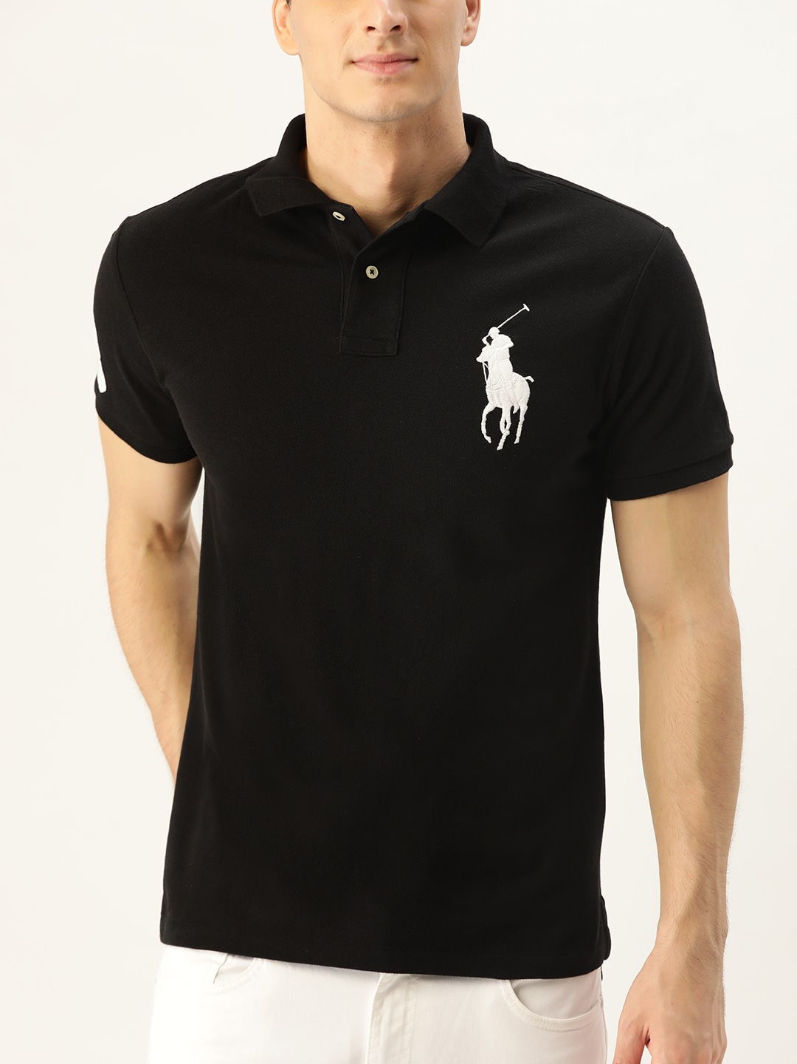

100% Original Products

Free Delivery on order above Rs. 799

Pay on delivery is available

Easy 7 days returns and exchanges

Try & Buy might be available

#### PRODUCT DETAILS

From its meticulous construction--our signature embroidered Big Pony alone requires a total of 10,800 individual stitches to produce--to its cotton mesh fabric, which only gets better with wear, Ralph Lauren's Polo shirt has been an icon of American style since 1972. This version is cut for a trim silhouette and finished with a "3" applique--the number typically worn by a polo team's strongest player

* Ribbed Polo collar
* Two-button placket
* Short sleeves with ribbed armbands
* Twill "3" applique at the right sleeve.
* Tennis tail
* Signature embroidered Big Pony at the left chest

#### Size & Fit

* Custom Slim Fit: a trim silhouette in between our Classic Fit and Slim Fit. Sleeve hugs the bicep. Tailored through the waist.
* Size M has a 68.6 cm front body length, a 71.1 cm back body length, a 44.4 cm shoulder and a 52.1 cm
* Model is 1.85 m and wears a size M.

#### Material & Care

100% cotton  
Machine-wash

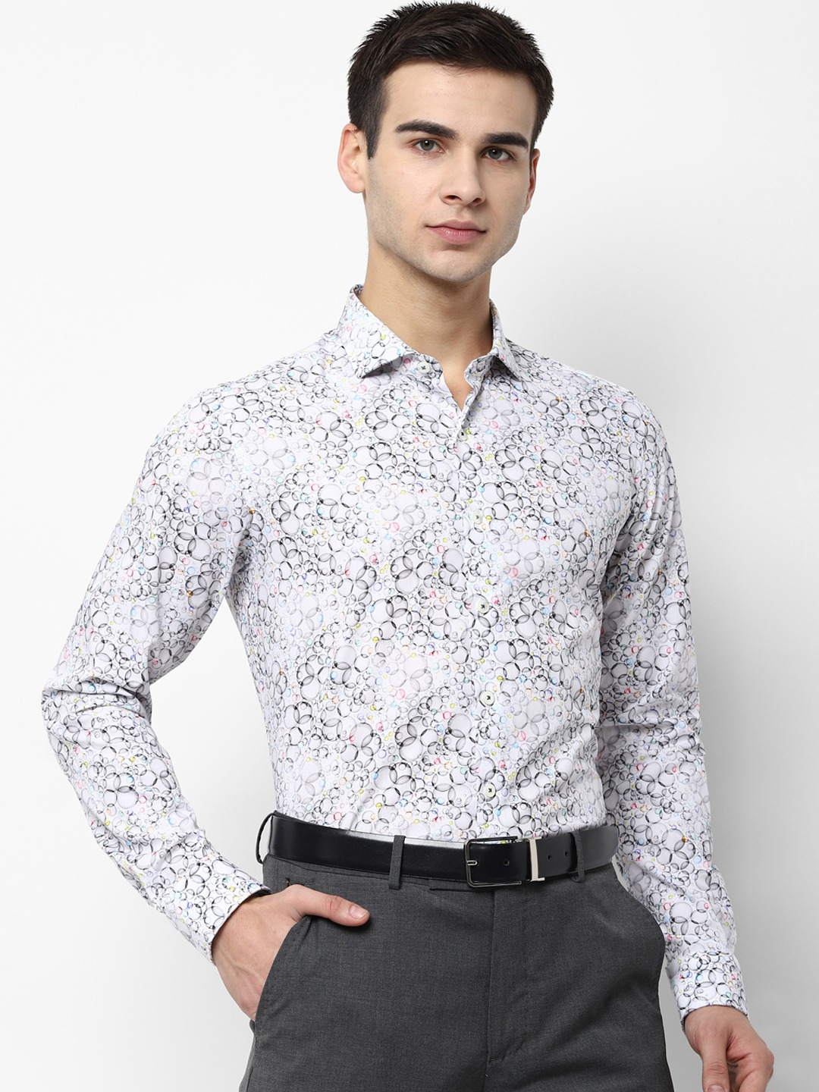

Price-6999Rs

#### PRODUCT DETAILS

White and Black printed formal shirt, has a spread collar, long sleeves, button placket, straight hem

#### Size & Fit

Regular Fit  
The model (height 6') is wearing a size 40

#### Material & Care

Material: 100% Cotton  
Machine Wash

#### Specifications

Sleeve Length

Long Sleeves

Collar

Spread Collar

Fit

Regular Fit

Print or Pattern Type

Geometric

Occasion

Formal

Length

Regular

Hemline

Straight

Placket

Button Placket

Placket Length

Full

Cuff

Button

Transparency

Opaque

Weave Pattern

Regular

Main Trend

Geometric Print

D3

[**Maison Margiela**](https://www.farfetch.com/in/shopping/men/maison-margiela/items.aspx) collarless single-breasted blazer

Specially crafted with a high-tech blend of materials made specifically to target long meetings, awkward lift chat and awful coffee, this blazer from Maison Margiela is here to hold your hand through the week. The only thing it can't do is your work. That's still on you, we're afraid. Featuring a collarless design, a concealed front fastening, long sleeves and sleek silhouette.

Made in Italy

D4

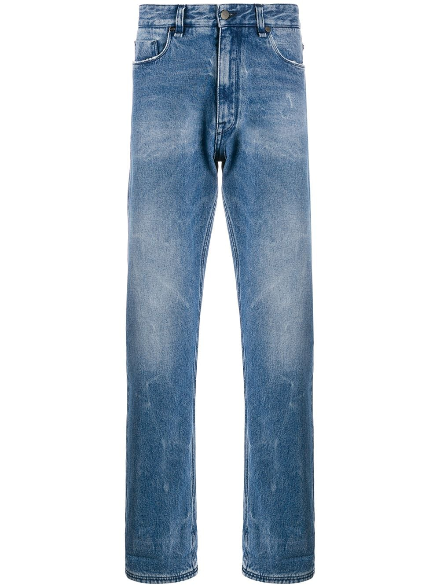

[**Fendi**](https://www.farfetch.com/in/shopping/men/fendi/items.aspx) baggy straight-leg jeans

Jane Eyre, Pride and Prejudice and Fendi denim - you love a good classic. These blue cotton baggy straight-leg jeans are best-seller material. Sartorial canon worthy, really. Featuring a button and zip fly, a five-pocket design, a leather brand patch to the rear and a faded effect.

Made in Italy

Price-760$

D5

[**Prada**](https://www.farfetch.com/in/shopping/men/prada/items.aspx) slim fit two-piece suit

Since its creation in 1913, Milanese fashion house Prada has been rooted in the uncompromising pursuit of quality, style, class and innovation. Tailored in Italy from a sumptuous blend of blue mohair and wool, this two-piece suit is a timeless investment piece that will follow you through the seasons. It features a jacket with notched lapels, long sleeves, a front button fastening, a chest pocket, two front pockets and a straight hem as well as slim-fit tapered trousers with a concealed front fastening, side pockets and rear pockets.

Price-3135$

D6

[**Balenciaga**](https://www.farfetch.com/in/shopping/men/balenciaga/items.aspx)Triple S clear sole sneakers

It is no surprise that anything Balenciaga conjures up rises to cult status. This season, expect more iconic handbags, contemporary footwear with a retro feel and logo-sprawled surfaces. These black Triple S bubble sneakers from Balenciaga feature a pull tab at the rear, a lace-up front fastening, a round toe, an embroidered logo, leather and mesh panels and a chunky rubber sole.

#### Composition

Lining: Polyamide 100%

Leather 100%

Outer: Polyamide 100%

Sole: Rubber 100%

Designer Style ID: 541624W09O1

### Wearing

Price-1030$

D7

[**Saint Laurent**](https://www.farfetch.com/in/shopping/men/saint-laurent/items.aspx)Andy low-top sneakers

Sold your 'sole' to style? So did these sneakers from Saint Laurent, and though they might have done a deal with the Devil, they'd rather be in your wardrobe than the underworld. But we have heard that Hades has a pair too.

#### Highlights

* black
* leather
* logo print to the side
* branded heel counter
* round toe
* front lace-up fastening
* flat rubber sole

Made in Italy

#### Composition

Outer: Leather 100%

Lining: Leather 100%

Sole: Rubber 100%

Designer Style ID: 6068330ZS00

D8

[**Balmain**](https://www.farfetch.com/in/shopping/men/balmain/items.aspx) black B-Runner mesh and nylon sneakers

black B-Runner mesh and nylon sneakers from Balmain.

Price-645$

#### Composition

Outer: Leather 100%, Fabric 100%

Lining: Leather 100%, Fabric 100%

Sole: Rubber 100%

Designer Style ID: UM0C240LSSH

D9

### **Product Details**

## PU upper

## Regular Fit

## Rubber sole

## Wipe with a clean, dry cloth when needed

## Product Code: 410239709006

Price-3000

D10

Price-4599

#### PRODUCT DETAILS

White solid formal shirt, has a cutaway collar, long sleeves, button placket, and curved hem

#### Size & Fit

The model (height 6') is wearing a size 32

#### Material & Care

Material: Cotton  
Machine Wash

#### Specifications

Sleeve Length

Long Sleeves

Collar

Cutaway Collar

Fit

Regular Fit

Print or Pattern Type

Solid

Occasion

Formal

Length

Regular

Hemline

Curved

Placket

Button Placket

Placket Length

Full

Cuff

Button

Transparency

Opaque

Weave Pattern

Regular

Main Trend

New Basics

D11

#### PRODUCT DETAILS

Blue dark wash 5-pocket mid-rise jeans, clean look with light fade, has a button and zip closure, waistband with belt loops

#### Size & Fit

Slim Fit  
Stretchable  
The model (height 5'8") is wearing a size 32

#### Material & Care

92% cotton, 6% polyester, 2% elastane  
Machine-wash

#### Price-6999rs

D12

Price-1799Rs

#### PRODUCT DETAILS

Navy Blue and Tan Brown solid reversible leather belt  
Reversible: Yes  
Stretchable: No  
Secured with a pull and twist closure

#### Size & Fit

Width: 3.4 cm

#### Material & Care

Leather  
Wipe with a clean, dry cloth to remove dust

#### Specifications

Material

Leather

Reversible

Yes

Occasion

Formal

Closure

Pull and Twist

Pattern

Solid

Multipack Set

Single

Stretchable

No

D13

Price-699Rs

#### PRODUCT DETAILS

Navy Blue and Tan Brown solid reversible leather belt  
Reversible: Yes  
Stretchable: No  
Secured with a pull and twist closure

#### Size & Fit

Width: 3 cm

#### Material & Care

Leather  
Wipe with a clean, dry cloth to remove dust

#### Specifications

Material

Leather

Reversible

Yes

Occasion

Formal

Closure

Pull and Twist

Pattern

Solid

Multipack Set

Single

Stretchable

No

D14

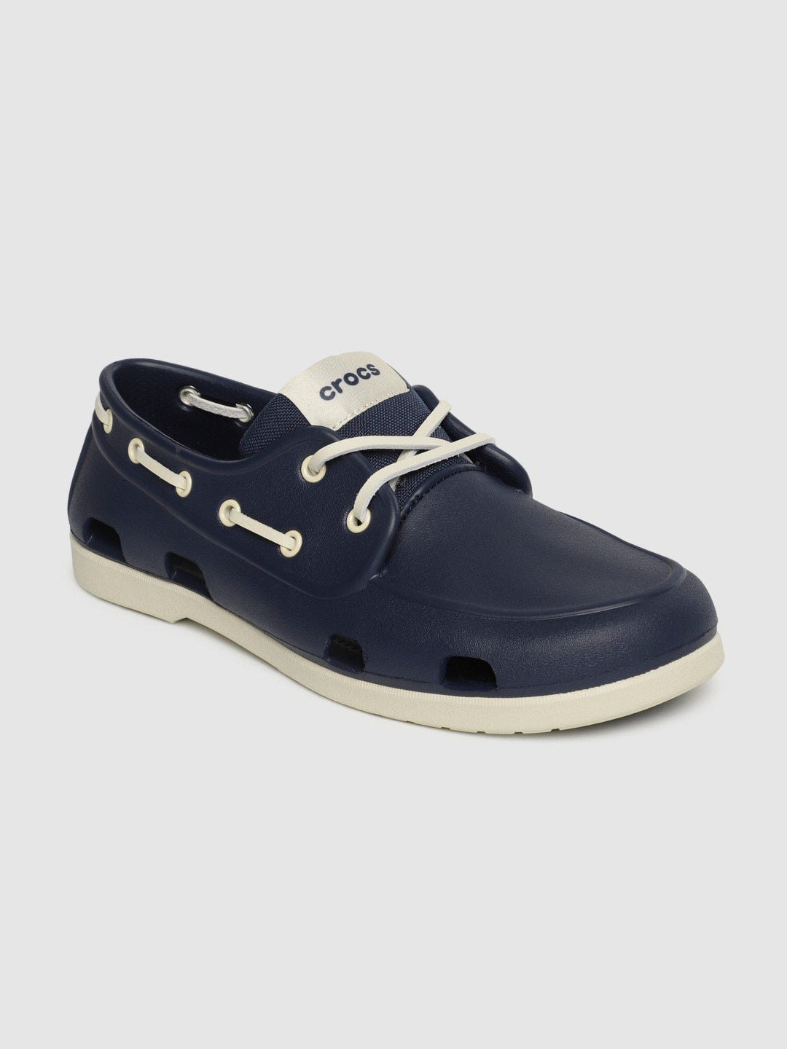

#### PRODUCT DETAILS

Price-4995Rs

A pair of round-toe navy blue boat shoes, has regular styling, slip-on detail  
Lightweight, fully molded Croslite material uppers  
Soft fabric tongues  
Stylish faux lacing  
Ventilation ports in the heel and forefoot add breathability and help shed moisture  
Rubberized, waterproof Croslite foam material outsoles feature increased traction  
Cushioned footbed  
Textured and patterned outsole  
Warranty: 3 months  
Warranty provided by brand/manufacturer

#### Material & Care

Synthetic  
Wipe with a clean, dry cloth to remove dust

#### Specifications

Type

Boat Shoes

Toe Shape

Round Toe

Pattern

Solid

Fastening

Slip-On

Shoe Width

Regular

Ankle Height

Regular

Insole

Comfort Insole

Sole Material

Synthetic

Micro Trend

Contrast Sole

Warranty

3 months

Occasion

Everyday

D15

Price-3199Rs

#### PRODUCT DETAILS

Black dark wash 5-pocket low-rise jeans, clean look, has a button and zip closure, a waistband with belt loops

#### Size & Fit

Glenn Slim fit  
The model (height 6') is wearing a size 32

#### Material & Care

99% cotton, 1% elastane  
Machine-wash

#### Specifications

Distress

Clean Look

Waist Rise

Low-Rise

Fade

No Fade

Shade

Dark

Fit

Slim Fit

Length

Regular

Waistband

With belt loops

Stretch

Stretchable

D16

Price-629rs

#### PRODUCT DETAILS

A pair of round-toe brown mojaris, has regular styling, slip-on detail  
Synthetic patent upper  
Cushioned footbed  
Textured and patterned outsole

#### Material & Care

Synthetic patent  
Wipe with a clean, dry cloth to remove dust

#### Specifications

Type

Mojaris

Toe Shape

Round Toe

Pattern

Solid

Fastening

Slip-On

Shoe Width

Regular

Technology

Massage Footbed

Ankle Height

Regular

Insole

Padded

Sole Material

TPR

Micro Trend

Basics

Occasion

Ethnic

D17

Price-2199

#### PRODUCT DETAILS

Beige and green self-design kurta with churidar  
Beige and green straight knee length kurta, has a mandarin collar, long sleeves, straight hem, side slits  
Beige solid churidar, drawstring closure  
Green and coral printed Nehru jacket

#### Size & Fit

The model (height 6') is wearing a size M

#### Material & Care

Top fabric: Silk Blend  
Bottom fabric: Silk Blend  
Machine-wash

#### Specifications

Sleeve Length

Long Sleeves

Top Shape

Straight

Top Type

Kurta

Bottom Type

Churidar

Top Pattern

Self Design

Top Design Styling

Regular

Top Hemline

Straight

Top Length

Knee Length

Neck

Mandarin Collar

Print or Pattern Type

Paisley

Bottom Pattern

Solid

Bottom Closure

Drawstring

Occasion

Festive

Weave Pattern

Regular

Weave Type

Machine Weave

Pattern Coverage

Large

D18

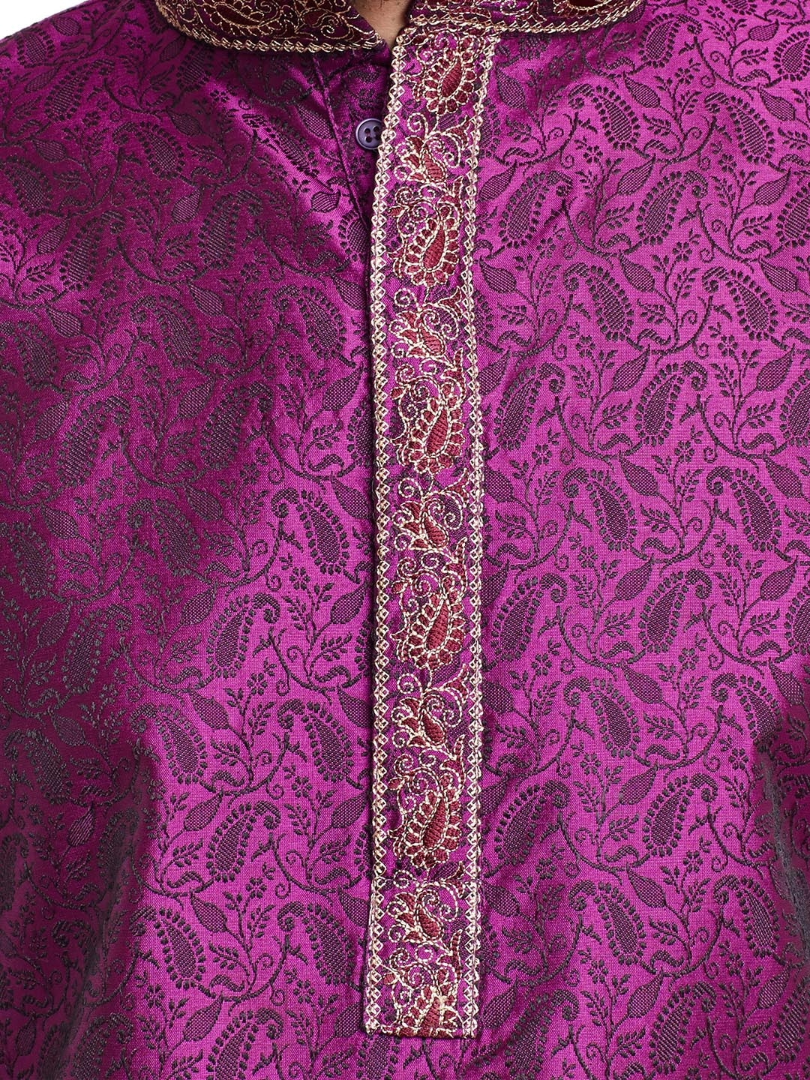

Price-1349Rs

#### PRODUCT DETAILS

Purple and white kurta pyjama  
Purple kurta with Jacquard woven detail, has a mandarin collar, a short button placket, long sleeves, side slits  
A pair of white pyjamas, has a waistband with drawstring fastening

#### Size & Fit

The model (height 6') is wearing a size L

#### Material & Care

Kurta fabric: 80% Jacquard silk, 20% cotton  
Bottom fabric: cotton  
Dry-clean

#### Specifications

Sleeve Length

Long Sleeves

Top Shape

Straight

Top Type

Kurta

Bottom Type

Pyjamas

Top Pattern

Self Design

Top Design Styling

Regular

Top Hemline

Straight

Top Length

Knee Length

Neck

Mandarin Collar

Print or Pattern Type

Solid

Bottom Pattern

Solid

Bottom Closure

Drawstring

Occasion

Daily

Weave Pattern

Regular

Weave Type

Machine Weave

D19

Price-3199

#### PRODUCT DETAILS

Brown and maroon sherwani with dhoti pants  
Brown printed sherwani, has a mandarin collar, full button placket, long sleeves, a chest pocket, multiple slits  
Maroon solid dhoti pants, has an elasticated waistband  
Comes with a pocket square.

D20

Price-2899Rs

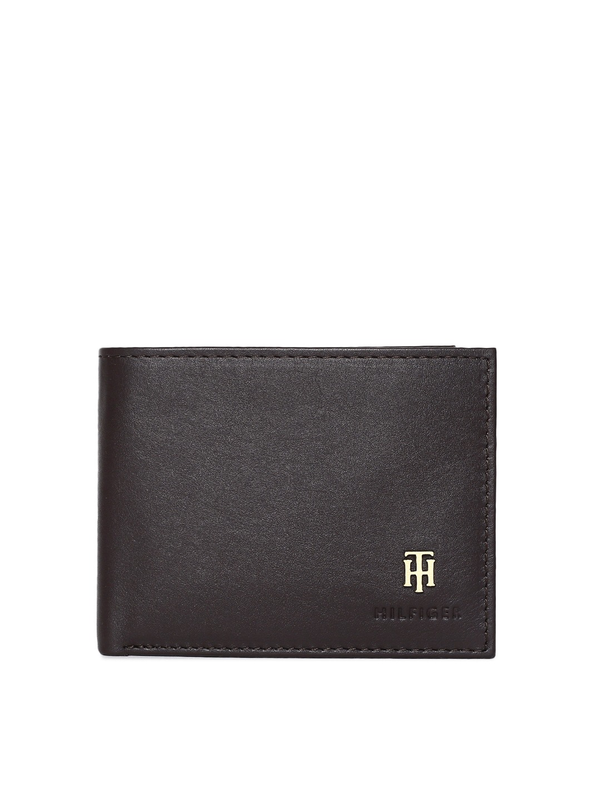

#### PRODUCT DETAILS

Brown solid two fold wallet  
1 main compartment, 7 card holders  
2 slip pockets and one id card holder  
Warranty: 6 months  
Warranty provided by brand/manufacturer

#### Size & Fit

Height: 8 cm  
Width: 9 cm

#### Material & Care

Leather  
Wipe with a clean, dry cloth to remove dust

D21

Price-3199Rs

#### PRODUCT DETAILS

Black textured two-fold wallet  
1 main compartment  
6 card holders, 1 slip pocket

#### Size & Fit

Height: 9 cm  
Width: 10.5 cm

#### Material & Care

Leather  
Wipe with a clean, dry cloth to remove dust